Rajith Radhakrishnan Lab Report 4 10/27/16

Board design - https://radrajith.github.io/ESE_323_PCB_Design/

During this week, Autodesk inventor was used to create the circuit board model. A rectangle was drawn with the exact dimensions of the board. 3 circle were placed at the exact same location as it is on the board and extrude tool was used to make it into holes. A rectangle with the length, width and height of the microprocessor was placed. A 14 pin header used for the LCD screen was placed with the correct dimensions, the screen shot of the model has been provided below. This lab was designed to get us used to the Inventor tools and UI.

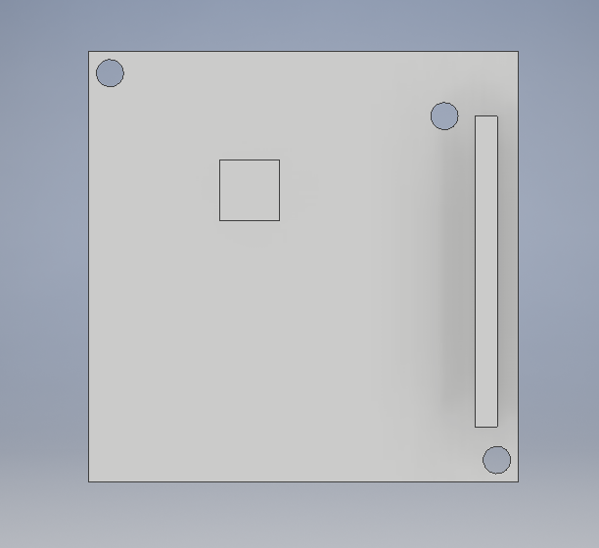

Front View

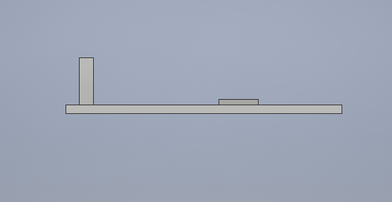

Side view